Rates of Reaction Questions

Method
Dilute hydrogen peroxide was put into a boiling tube and a small amount of manganese dioxide added. A delivery tube connected to a syringe was quickly fitted to the boiling tube and the time taken to get 10 mL of gas in the syringe was measured.
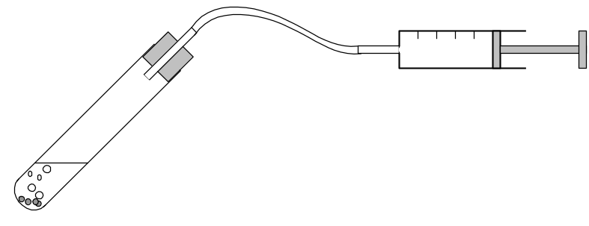

Manganese dioxide
Syringe

Hydrogen peroxide

The temperature of the hydrogen peroxide was changed to see if the temperature of the reactants affected the rate of gas production.

Time (seconds) | 31 | 24 | 18 | 13 | 9 | 6 | 4
Temperature (ºC) | 20 | 25 | 30 | 35 | 40 | 45 | 50

1. Name the gas produced in the reaction.

___________________________________________________________________________

2. Write a conclusion for the experiment.

____________________________________________________________________________
____________________________________________________________________________
___________________________________________________________________________

3. The Method describing how the experiment was done (at the beginning of Part B) failed to ensure that it was either a valid or reliable experiment.

(a) What should have been done to make the results valid?

____________________________________________________________________________
____________________________________________________________________________
(b) What should have been done to make the results reliable?

____________________________________________________________________________
____________________________________________________________________________

4. A second investigation was done on this reaction, but this time the amount of MnO₂ used was varied while all other factors were kept constant. The student’s result suggested that the amount of MnO₂ added made no difference to the rate of decomposition of H₂O₂.

(a) Assuming that the student’s results in both experiments were valid and reliable, what can you say about the role of the MnO₂ in the reaction?

____________________________________________________________________________
___________________________________________________________________________
(b) Suggest another way that you could increase the rate of decomposition (apart from what ` has already been done in the two experiments).

____________________________________________________________________________
_________________________________________________________________Part C: Hydrogen.
Draw a labelled diagram of the apparatus you would set up to collect a test tube of hydrogen gas. The technique you are to use is called “downward displacement of water.” Clearly label the chemicals used.

